StockPrices Head Output - Explanation
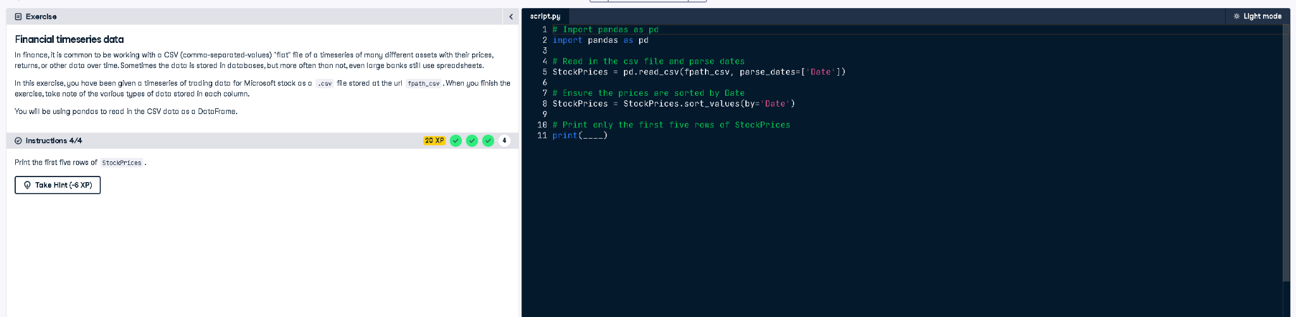

Python Code
# Import pandas as pd
import pandas as pd
# Read in the csv file and parse dates
StockPrices = pd.read_csv(fpath_csv, parse_dates=['Date'])
# Ensure the prices are sorted by Date
StockPrices = StockPrices.sort_values(by='Date')
# Print only the first five rows of StockPrices
print(StockPrices.head())

Explanation (in simple words)
This code imports pandas, loads stock price data from a CSV file while converting the 'Date' column into date format. It sorts the data by the date column so it’s in chronological order. Finally, it prints the first 5 rows of the data using the head() function.

